📊 Milestone 3 — DAX & Business Metrics (Individual Report)
AI-Driven Revenue Analysis for Hotels

1. Introduction
The hospitality industry generates extensive booking data that contains valuable information about revenue, customer behavior, demand patterns, and operational performance. However, without structured analysis, this data cannot be effectively utilized for decision-making.
This project aims to analyze hotel booking data using Power BI to derive meaningful insights related to revenue performance, occupancy trends, cancellation behavior, and future demand. Milestone 3 focuses on applying Data Analysis Expressions (DAX) to develop business metrics and building advanced dashboards that provide actionable insights.

2. Objective of Milestone 3
The primary objective of this milestone is to create key performance indicators using DAX and analyze hotel performance through interactive dashboards. This phase aims to identify major revenue drivers, evaluate pricing effectiveness, understand occupancy patterns, assess cancellation impact, and forecast future trends.

3. Development of DAX Measures
DAX was used to create several analytical measures that summarize and interpret the booking data dynamically. These measures update automatically based on filters applied in the dashboard.
3.1 Total Revenue
Total Revenue represents the overall income generated from confirmed bookings. It serves as the primary indicator of financial performance.
3.2 Average ADR (Average Daily Rate)
Average ADR indicates the average price charged per room per night. This metric reflects pricing strategy and demand-based pricing effectiveness.
3.3 Revenue per Booking
Revenue per Booking measures the average income generated from each reservation, providing insight into customer value.
3.4 Total Bookings
Total Bookings represents the number of reservations made during the analysis period and indicates overall demand.
3.5 Occupancy Rate
Occupancy Rate measures the proportion of available room capacity that is utilized. It reflects operational efficiency and demand intensity.
3.6 Cancellation Rate
Cancellation Rate indicates the percentage of bookings that were canceled, highlighting reliability of reservations and potential revenue risk.
3.7 Revenue Lost
Revenue Lost quantifies the financial impact of canceled bookings, helping assess the economic consequences of cancellations.
3.8 Revenue Growth
Revenue Growth measures the increase or decrease in revenue over time, providing insights into performance trends.
3.9 Last 12 Months Revenue
This metric represents revenue generated in the most recent twelve-month period, offering a view of current performance.

4. Revenue Performance Analysis
The Revenue Performance dashboard examines how income varies across time, hotel types, customer segments, and room categories.
The analysis reveals seasonal trends in revenue, with noticeable fluctuations across months and years. Revenue comparison between City Hotel and Resort Hotel provides insights into property performance differences. Additionally, revenue distribution across customer types helps identify the most profitable segments.
Geographic analysis highlights the countries contributing most to revenue, while room type analysis identifies which categories generate the highest income. The Average ADR trend further indicates how pricing varies across months.
Overall, this dashboard provides a comprehensive view of factors influencing revenue generation.
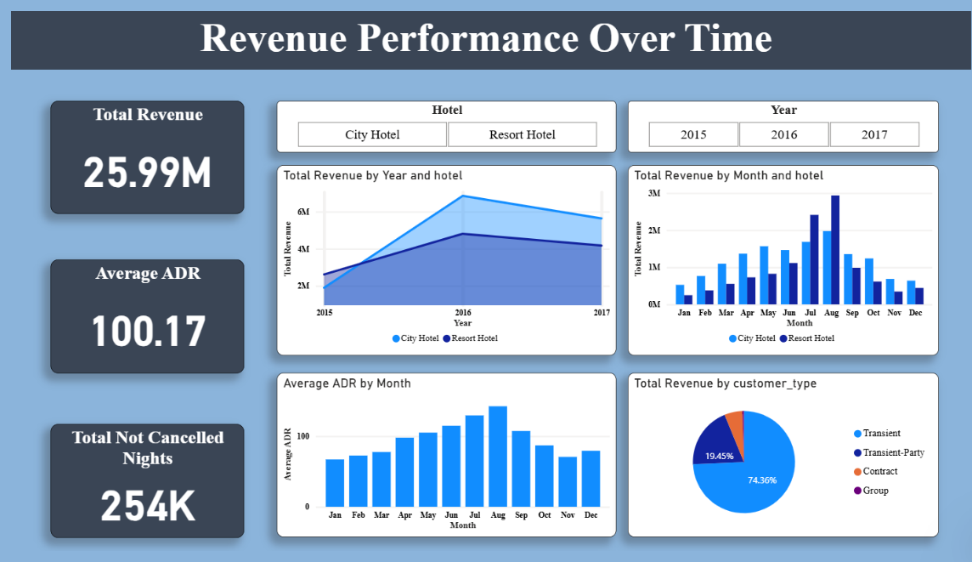

5. Occupancy and Demand Analysis
The Occupancy and Demand dashboard focuses on how efficiently hotel capacity is utilized and how customer demand evolves over time.
Occupancy rates were compared between City and Resort hotels, revealing differences in utilization patterns. Monthly occupancy trends highlight peak seasons and low-demand periods. Booking trends also indicate variations in customer demand across different months.
Capacity utilization insights help hotel management optimize staffing, pricing strategies, and resource allocation.
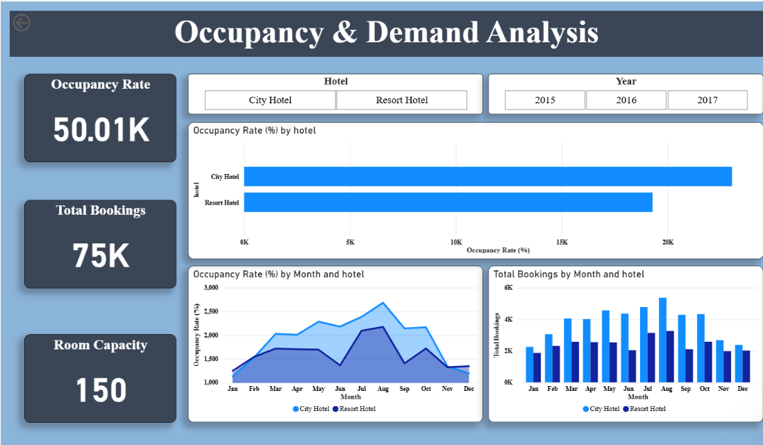

6. Cancellation Behaviour and Revenue Loss Analysis
Cancellations pose a significant challenge to revenue stability. This dashboard analyzes cancellation patterns and their financial implications.
The overall cancellation rate indicates the proportion of reservations that do not result in actual stays. Revenue lost due to cancellations represents a substantial financial impact. Analysis by market segment identifies which customer groups contribute most to lost revenue.
Monthly trends show how cancellation behavior changes throughout the year, providing insights for risk mitigation strategies.
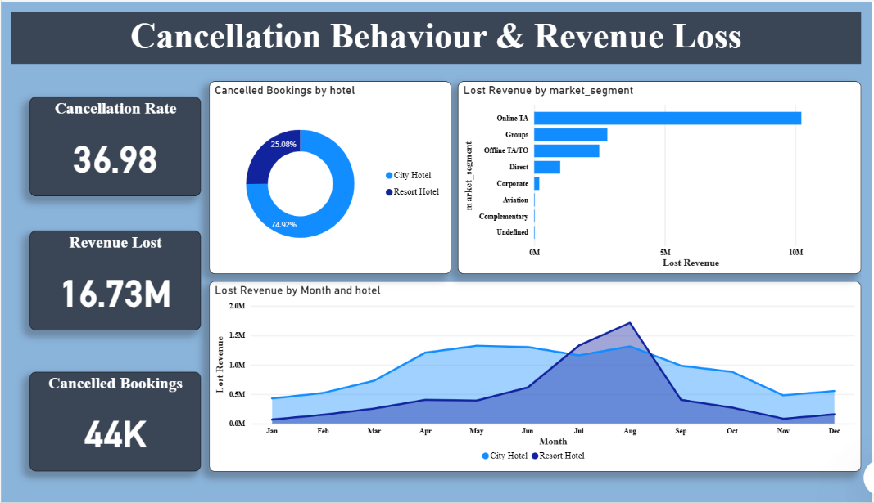

7. Revenue Forecasting Analysis
The forecasting dashboard evaluates future revenue trends based on historical performance.
Key indicators include revenue growth percentage, average monthly revenue, and revenue generated during the last twelve months. A forecasted revenue curve provides an estimate of future performance, enabling proactive planning.
Forecasting helps hotel management make informed decisions regarding pricing strategies, capacity planning, budgeting, and marketing efforts.

8. Interactive Features
The dashboards include interactive filters that allow users to explore the data dynamically.
Users can filter results based on:
- Hotel type (City or Resort)
- Market segment
- Year
- Customer categories
These interactive features enable detailed analysis tailored to specific conditions and improve usability for decision-makers.

9. Key Insights Derived
Several important insights were obtained from the analysis:
- City hotels generate higher overall revenue compared to resort hotels.
- Online travel agency bookings contribute significantly to total revenue.
- Demand peaks during mid-year months.
- Cancellations lead to substantial financial losses.
- Pricing and stay duration have a strong influence on revenue outcomes.
These findings highlight critical areas for revenue optimization.

10. Business Value of the Analysis
The insights derived from this project can assist hotel management in:
- Optimizing pricing strategies
- Improving occupancy planning
- Reducing the impact of cancellations
- Identifying high-value customer segments
- Supporting strategic decision-making
Such data-driven insights can enhance operational efficiency and profitability.

11. Conclusion
Milestone 3 successfully utilized DAX to develop key business metrics and produced advanced dashboards that provide comprehensive insights into hotel revenue performance, demand patterns, cancellation behavior, and future trends.
The analytical tools developed in this phase enable stakeholders to make informed decisions, improve planning, and enhance overall business performance.

12. Future Scope
Future enhancements to the project may include:
- Integration of real-time booking data
- Predictive analytics using machine learning
- Customer segmentation analysis
- Automated pricing optimization
These advancements can further strengthen decision-support capabilities.

